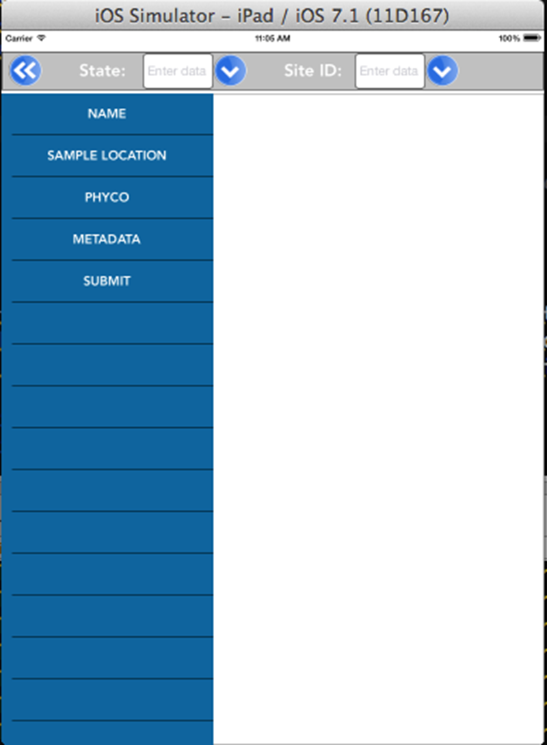This page may not be necessary. Maybe all we need is a welcome page and then something that leads you to the next page, such as: “Welcome to the New England Cyanobacteria Monitoring and Bloom Watch Program page” a brief explanation of what it is and then…..What would you like to do? 1. Collect a sample from within the lake

2. Collect a sample from the shoreline

3. Take a picture & report a suspected harmful algal bloom. This option should be linked in some form to the “Dirty Dozen” cyanobacteria key developed by the University of New Hampshire.

* No matter what, the answer to any of the questions leads you to the weather and surface condition fields, the date, the geo location, sampling or observer name/s first.
* A logical data input flow emanates from here.
* The “Dist: 3 or 1 meter” should actually be listed as “depth.”
* The “other (m)” field should have a boundary set so that the number has to be less than three meters with one decimal place so it can record in tenths of meters.
* Latitude/Longitude should either be so that GPS position can be automatically input directly from the smartphone, or from a series of drop downs; one for degrees, one for minutes, and one for seconds. Bounds should be set to keep it in the New England area. Possibly same approach for decimal degrees; maybe a conversion formula could be built in to the database to automatically convert. I would have to ask Bryan about this.
* Time should be a drop down, probably in 15 minute increments.
* The format/sequence of WL- and SS- fields should be rearranged to be in a logical flow sequence for when folks are out in the field.
* Possibly need a field for water/air temp? Will need to discuss.
* Needs to be a check box or drop down to designate if samples were analyzed prior to freezing/pre-filtering/post filtering/after thawing/ at standard temp after thawing.

[THERE ALSO NEEDS TO BE AN ORDER LOGICAL SEQUENCING FOR SAMPLES THAT ARE JUST COLLECTED AND THEN FROZEN AND THEN READ AFTER LEAVING THE FIELD AT SOME POINT AND TIME. THIS WILL HAVE TO BE THOUGHT THROUGH A LITTLE MORE]

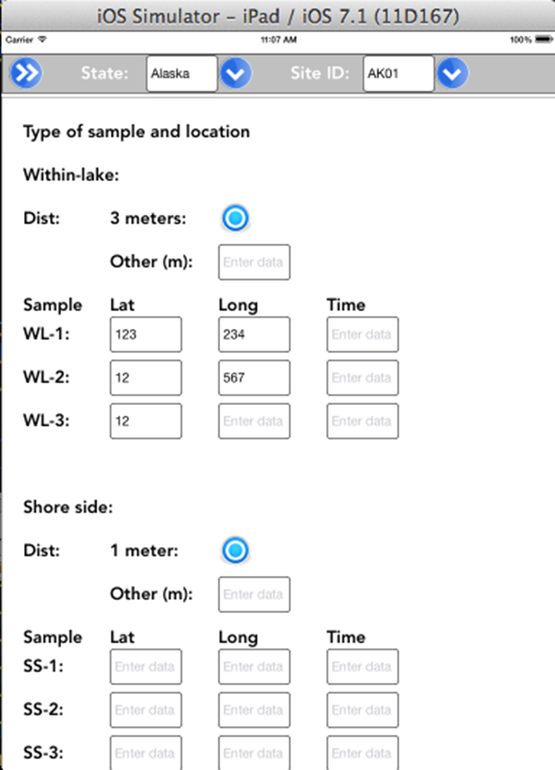

* 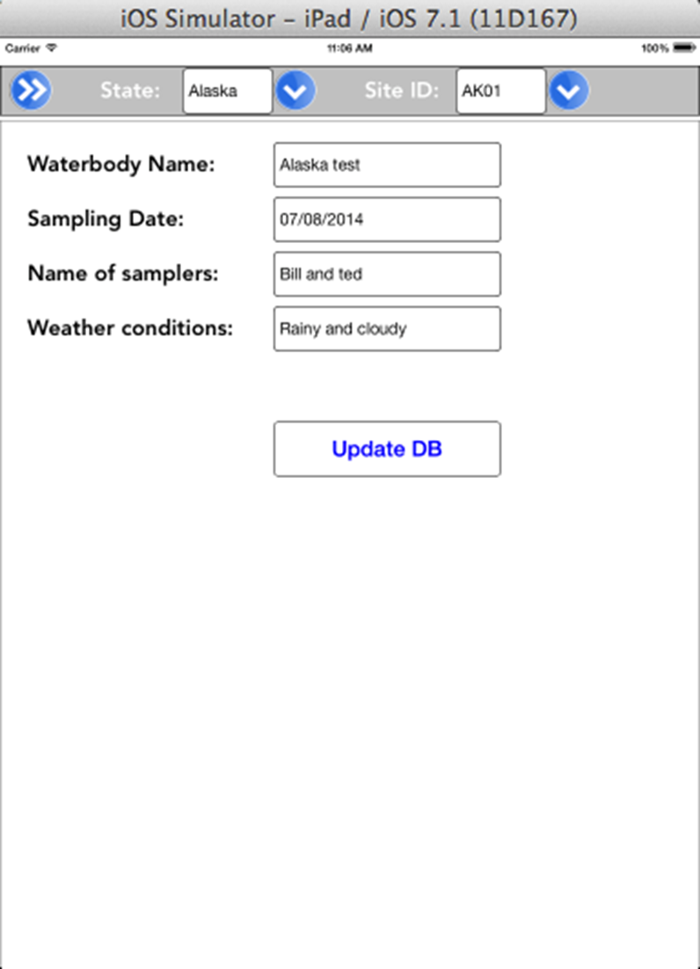State field should just be a drop down with the six New England states and New York
* Site ID should be a specific identifier utilized by the state/entity sampling, that can later be linked to NHD or like.
* Waterbody name should be the common name found on a local map/gazetteer. Should be uniform case. Once the name has been entered, it should be available from then on via the drop down list.
* Sampling date should be a calendar for consistent and uniform input.
* Name of Samplers should be full names with uniform case. The field should also be able to populate a drop down list, so that once a name is entered, it then begins to appear in the drop down selection from there on out.
* Weather conditions are selected from the drop down list. Uniform case text to keep the database clean.
* Before update to the database can happen, certain fields must be mandatory to be filled out. This would include at least one complete sampling field (not including the bloom watch component), name of sampler/observer, date, time, GPS location, weather, and surface conditions.